**VIDEO BASED SURVEILLANCE SYSTEM AND PATH PREDICTION**

S.Omezhile

Department of Computer Science

4th Year

Panimalar Engineering College

[Omshiv2427@gmail.com](mailto:Omshiv2427@gmail.com)

P.Pooja

Department of Computer Science

4th Year

Panimalar Engineering College

[pooja.prakash2101999@gmail.com](mailto:pooja.prakash2101999@gmail.com)

Ms.V.Sathiya

Asst.Professor

Department of Computer Science

Panimalar engineering College

[deviviji2000@gmail.com](mailto:deviviji2000@gmail.com)

***Abstract***- **In this paper,We propose a method to Find and detect the criminal using facial recognition and find his further movement by predicting his path.As an important branch of Security and surveillance system,face recognition technology has the characteristics of convenient acquisition and high reliability that is widely used in the fields of information security, national security,Traffic monitoring and security and organisations like school, college. This project is to Detect Unknown or specified given persons(criminal) in Surveillance cameras at Traffic signals and predicting his probability path further then reporting to their nearby located control rooms .We used a CNN Algorithm to better accuracy and precision and open source for path prediction.**

***Keywords*-Artificial intelligence,IOT,Convolutional neural network(CNN),path prediction.**

1.INTRODUCTION

Artificial intelligence paves the way for computers to think like humans. Machine learning makes the way more even by adding training and learning components. The availability of huge dataset and high performance computers lead the light to deep learning concepts, which automatically extract features or the factors of variation that distinguish objects from one another. Among the various data sources which contribute to terabytes of big data, video surveillance data is having much social relevance in today’s world. The widespread availability of surveillance data from cameras installed in residential areas, industrial plants, educational institutions and commercial firms contribute towards private data while the cameras placed in public places such as city centers, public conveyances and religious places contribute to public data. Analysis of surveillance videos involves a series of modules like object recognition, action recognition and classification of identified actions into categories like anomalous or normal. This survey gives specific focus on solutions based on deep learning architectures. Among the various architectures in deep learning, commonly used models for surveillance analysis are CNN, auto-encoders and their combination and path prediction by open source for better enhancement in security and surveillance domain.

2.CNN WORKS

**A.TYPES OF LAYERS**

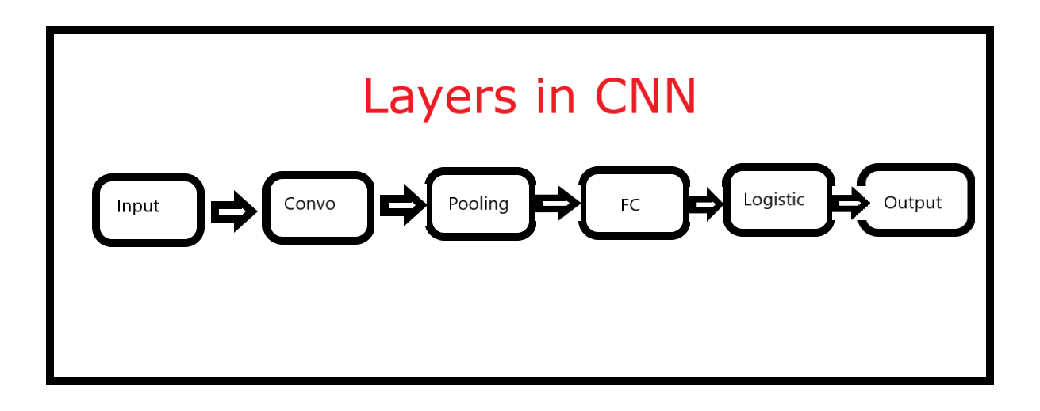

**A.1.Input layer**

Image data should be included in the CNN input layer. As we saw earlier, image data is represented by a three-dimensional matrix. You must resize it to fit into a single column. If you have a 28 x 28 = 784 image, you must convert it to 784 x 1 before feeding it into the input. If you have "m" training instances, the input dimension would be "m" (784, m).

**A.2.Convo Layer**

The Convo layer is also called the Feature Extractor Layer because it extracts features from the image. To begin, a portion of the image is connected to the Convo layer, which performs the convolution operation we saw earlier as well as calculating the dot product between the receptive field (a local region of the input image the same size as the filter) and the filter.The operation yields a single integer representing the output volume. Then we use a Stride to slide the filter over the next receptive field of the same input image and repeat the procedure. We'll keep repeating the process until we've gone through the entire image. The output would be the next layer's input.

ReLU activation is also present in the Convo layer, which reduces all negative values to zero.

**A.3.Pooling Layer**

After convolution, a pooling layer is used to reduce the spatial volume of the input signal. It's used in the middle of two convolution layers. It would be computationally costly to apply FC after the Convo layer without using pooling or max pooling, which we do not want. As a result, the only way to reduce the spatial volume of the input image is to use maximum pooling.



You can observe the 4 x 4 dimension input is reduced to 2 x 2 dimension.

The pooling layer has no parameters, but it does have two hyperparameters: Filter(F) and Stride (S). In general, if we have W1 x H1 x D1 as input dimensions, then

W2 = (W1−F)/S+1

H2 = (H1−F)/S+1

D2 = D1

W2, H2, and D2 are the output width, height, and depth, respectively.

**A.4.Fully Connected Layer**

Weights, biases, and nerves are all part of the completely connected layer. It binds neurons from one layer to those from another. It is used to train people to identify images into various categories.

**A.5.Logistic Layer**

The last layer of CNN is the logistic layer. It is located at the bottom of the FC layer. Softmax is used for multi-classification and logistic is used for binary classification.

**A.6.Output Layer**

Output layer contains the label which is in the form of one-hot encoded.Now you have a good understanding of CNN. Let’s implement a CNN in Keras.

3.TELEGRAM BOT

Telegram began as a mobile messaging app that authorized users to send and receive text and multimedia messages to and from one another. There are a lot of messenger apps out there, but what makes this one stand out is the fact that it has a lot of features.

Data encryption and the ability to encrypt data are also security features.

Programming allows you to build Telegram Bots with a variety of functions.

The Telegram Bot API is used in this code.

1) Telegram Bot: A Telegram Bot is a computer that uses the Telegram messaging app. It's true.

It was designed to perform the same tasks as a single user, but it is not.

Artificial Intelligence may be used to manipulate computer features.

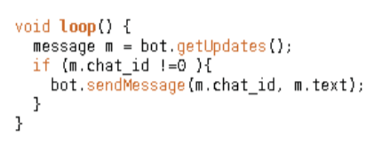

2) Telegram Bot API: The Telegram Bot API is a series of functions that allows you to create Telegram Bots using programming languages like Python, Java, C/C++.. The Telegram Bot dynamic defines the rules for interacting with other Telegram Bots and individual users.

4.PATH PREDICTION

Predicting the specified person path by directing his further path whether he moves Left or Right.

By using the X and Y axis to detect up or down of the face movement and for the Horizontal movement it uses -X and +X Movement.

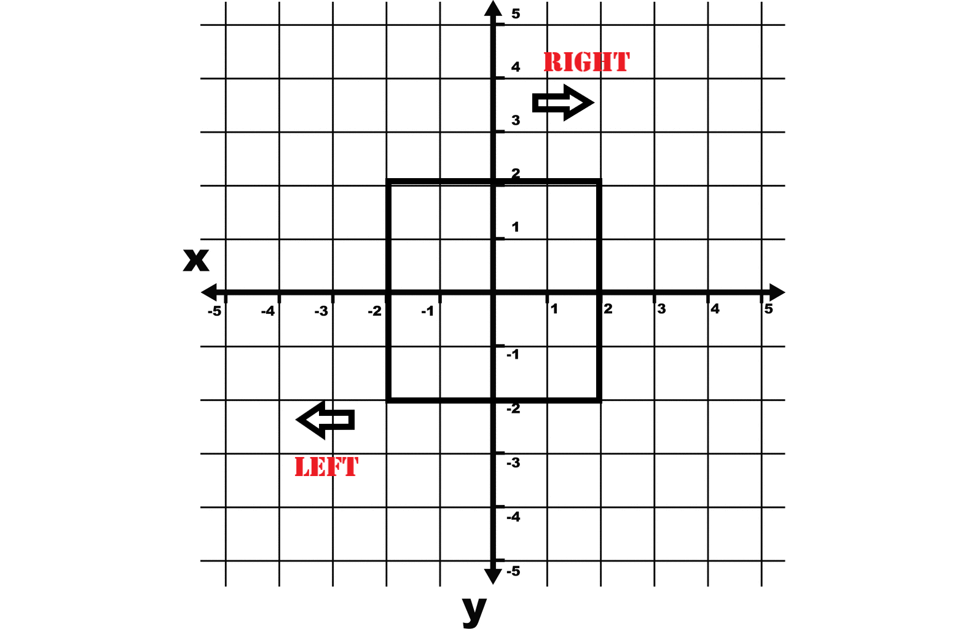

4.System Architecture

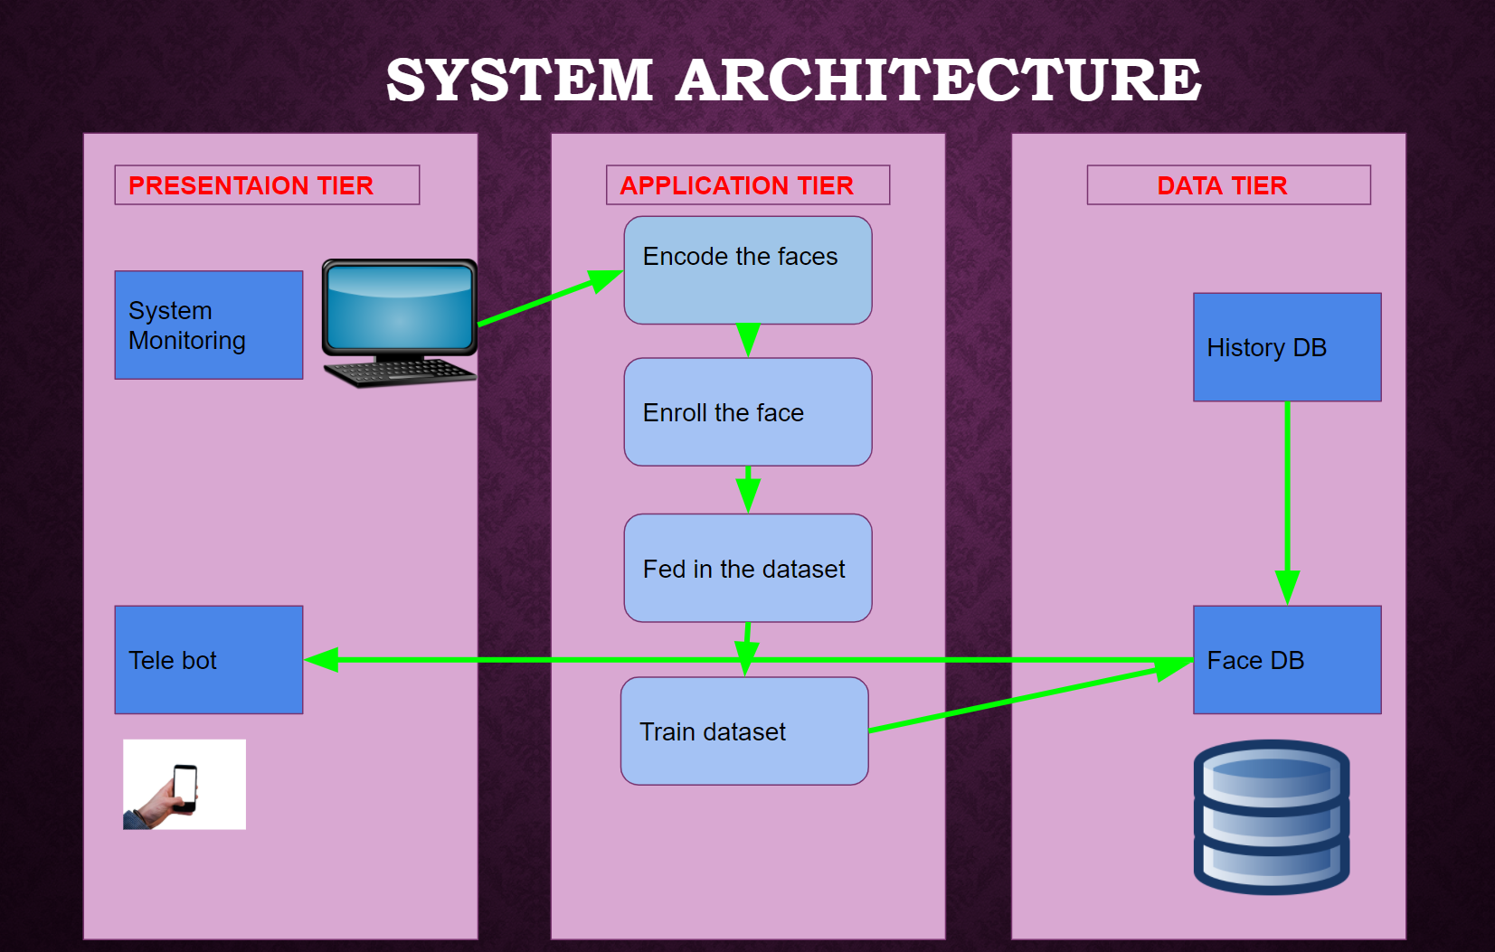

5.CONCLUSION

This project is used to implement face recognition. Face recognition nowadays has been widely used in many areas especially on security. Traffic security can be improved with the implementation of this Idea. The improvement of technology has made the internet of things no longer an expensive thing and it can be modified and customized depending on our needs.

The statistical report said 55% of the theft was found with the help of CCTV and Developing countries like China Encourage Face Recognition system in CCTV to defend themselves from theft and criminal activities.

This Proposed Idea used to detect and find that specified person path so implementing this project will surely help to detect and Find thieves easily.

6.REFERENCES

1.Bewley, A., Z. Ge, L. Ott, F. Ramos, and B. Upcroft. 2016. “Simple online and realtime tracking.” In Proc., 2016 IEEE International Conference on Image Processing (ICIP), 3464–3468. New York: IEEE

2.Davis, J W and Bobick, A F, “The representation and recognition of action using temporal templates” IEEE Conference on Computer Vision and Pattern Recognition

3.Makris, D and Ellis, T “Finding Paths in Video Sequences”, BMVC2001,Manchester, England, September 2001.

4.Guo, Q., Wang, Z., Wang, C., & Cui, D. (2020). Multi-face detection algorithm suitable for video surveillance. 2020 International Conference on Computer Vision, Image and Deep Learning (CVIDL). doi:10.1109/cvidl51233.2020.00013

5.Path Detection in Video Surveillance Dimitrios Makris and Tim Ellis Information Engineering Centre, City University, London

6.Hongwei Qin, Junjie Yan, Xiu Li, and Xiaolin Hu. 2016. Joint training of cascaded CNN for face detection. In CVPR.